1811ICT/2807ICT/7001ICT Programming Principles Workshop 6

School of Information and Communication Technology

Griffith University

|  |  |
| --- | --- |
| Goals | In this workshop we practice programming with strings and functions |
| When | Week 7 |

# Before your workshop class:

* Read this whole document.
* Review the lecture notes sections 1 to 16.

# Workshop activities

At any stage, when you are stuck, *ask your workshop instructor*!

## Problem 1

*Problem:* Write a program that prompts for and reads strings until a string that starts with the letter “A” is entered (inclusive), then prints the longest string that was entered. Example run:

Enter a string: In realms where dreams and magic meet,

Enter a string: Where wonders never fail,

Enter a string: There lies a world of fantasy,

Enter a string: the land of fairytale.

Enter a string: With castles tall and dragons fierce,

Enter a string: And forests dark and deep,

Longest was: In realms where dreams and magic meet,

*Testing*: Test your code for the example input shown above.



How would you change the code to address a situation where after many prompts an “A” is never entered?

## Problem 2

*Problem:* Write a program with a **function** that converts all numerical digits in a string to the underline character. Example run:

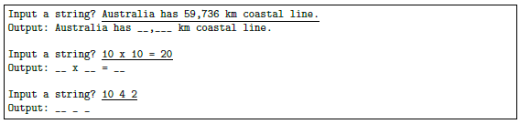

*Testing*: Test your code for the example input shown above.



How would you change the code to let the user enter their replacement character of choice, that is which character you should use in the place of all numerical digits?

## Problem 3

*Problem:* Given starting and ending years, write a program with a **function** to calculate the number of days from the starting year to ending year inclusive. Hints: Write a **function** to check for a leap year. Sample code is in the lecture notes of Section 10: Type Bool and Boolean Expressions. Sample run:

Year 1? 1980

Year 2? 2022

Number of days: 15706

*Testing*: Test your code for the example input shown above.



How would you check whether the years that were entered are valid? How would you change the code to request the user to enter the year until a valid value has been entered?

## Problem 4

*Problem:* A roll carpet comes in rolls that are 3.66 meters wide. Carpet is charged by the total number of **whole metres** that need to be cut from the roll. It may be laid in a rectangular room in a lengthways manner or widthways manner (see illustration below). Either way, there might be some wastage. The length of a room is always its longer dimension, and its width is always its shorter dimension.

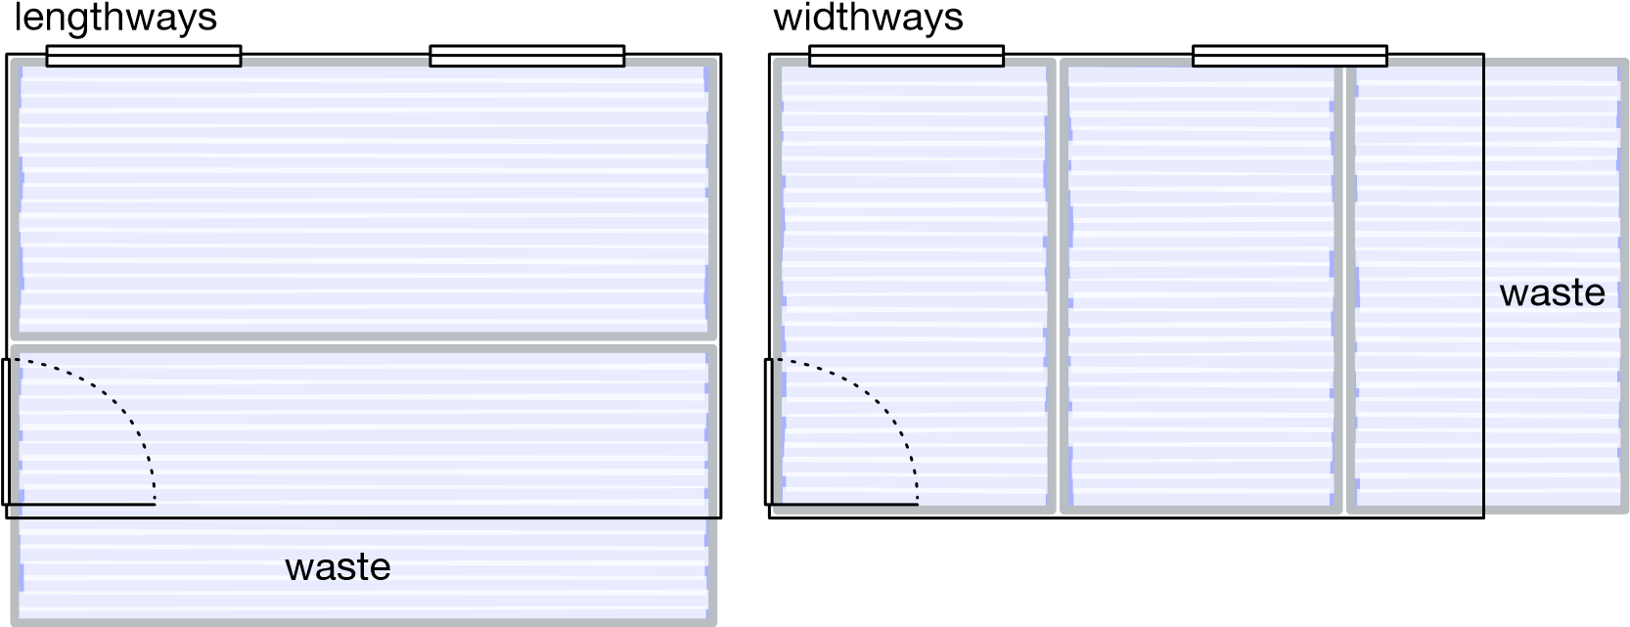

Write a program that repeatedly asks the user for room dimensions until either dimension entered is zero. For each room print the length and width (to the nearest millimetre), and the total length of carpet required in **whole metres**, to cover the room in two scenarios: lengthways manner and widthways manner. Hints: make good use of standard library functions; and simplify your program by writing a function to compute the total carpet length required given the room dimensions.

Example run:

Enter room dimension 1 (m): 2.5

Enter room dimension 2 (m): 5.5

Length of room = 5.500 m

Width of room = 2.500 m

Total carpet length required in lengthways manner = 6 m

Total carpet length required in widthways manner = 5 m

Enter room dimension 1 (m): 7.4

Enter room dimension 2 (m): 4.3

Length of room = 7.400 m

Width of room = 4.300 m

Total carpet length required in lengthways manner = 15 m

Total carpet length required in widthways manner = 13 m

Enter room dimension 1 (m): 0

*Testing*: Test your code for the example input shown above.



What do you need to check to ensure that only valid values are entered? How would you change your code to check for this?

How would you change the code above to provide the same information, but also adding a recommendation for using the least amount of carpet?

Example run:

Enter room dimension 1 (m): 2.5

Enter room dimension 2 (m): 5.5

Length of room = 5.500 m

Width of room = 2.500 m

Total carpet length required in lengthways manner = 6 m

Total carpet length required in widthways manner = 5 m

Enter room dimension 1 (m): 7.4

Enter room dimension 2 (m): 4.3

Length of room = 7.400 m

Width of room = 4.300 m

Total carpet length required in lengthways manner = 15 m

Total carpet length required in widthways manner = 13 m

Enter room dimension 1 (m): 0

To use the least amount of carpet you should use the following layout:

Room 1, 2.5mx5.5m: widthways

Room 2, 7.4mx4.3m: widthways



## Problem 5

*Problem:* Write a program to manage a bank account’s balance. The program should include a global variable to store the account balance, and functions to update the balance based on deposits and withdrawals.

Example run:

Opening balance of account: 500

Amount deposited or withdrew (negative value): 40

Amount deposited or withdrew (negative value): -20

Amount deposited or withdrew (negative value): -50

Amount deposited or withdrew (negative value): 20

Amount deposited or withdrew (negative value): 0

Opening balance: 500

Deposits: 60

Withdrawals: 70

Closing balance: 490

Why did we use a global variable? What will happen if we do not use a global variable?



*Testing*: Test your code for the example input shown above.

## Problem 6

*Problem:* Write a program to manage the inventory of a store for books and pens. A customer can buy a combination of books and pens, but you cannot sell them items that are not in stock. When there are only 5 books or pens left, you need to provide a message that new stock must be ordered and for which item. If a customer buys items or stock has been ordered, you must update the quantity of each item accordingly.

Example run:

Number of pens in stock: 80

Number of books in stock: 50

Number of pens requested by customer: 30

Number of books requested by customer: 2

Number of pens in stock: 50

Number of books in stock: 48

Number of pens requested by customer: 25

Number of books requested by customer: 10

Number of pens in stock: 25

Number of books in stock: 38

Number of pens requested by customer: 30

There are only 25 pens in stock. Do you want to buy the 25 pens? Y/N: Y

New pens must be ordered.

Number of books requested by customer: 20

Number of pens in stock: 0

Number of books in stock: 18

Number of pens requested by customer: 0

Number of books requested by customer: 0

Number of pens in stock: 0

Number of books in stock: 18

*Testing*: Test your code for the example input shown above.



What do you need to check to ensure that only valid values are entered? How would you change your code to check for this?



Well done for finishing these activities!